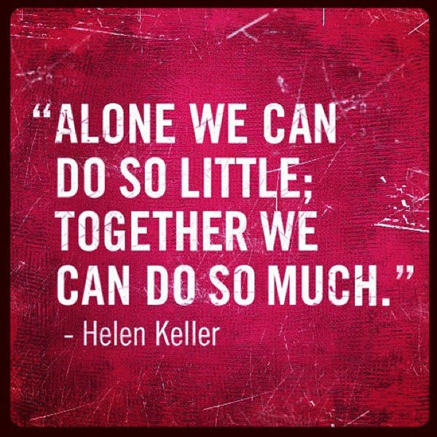

SAFE

RESPECTFUL

RESPONSIBLE

The Fox Hollow staff, scholars, and parents agree that this compact outlines how we will share the responsibility for improved student academic achievement, by which the school and parents will build and develop a partnership that will help reach our goal of providing a world class education for all scholars.

‘Owl’ Be Your Champion!

School & Family

Compact

Fox Hollow Elementary

## FHES Scholars are:

Fox Hollow Elementary School

### 2020-2021

8309 Fox Hollow Drive

Port Richey, FL 34668

(727) 774-7600

#### School & Family Compact

Scholars will share the responsibility to improve academic achievement and reach their highest potential. Specifically, scholars will:

* attend school regularly.
* complete classwork and homework on time and with effort.
* follow the school-wide rules.
* read 30 minutes every school night.

*Scholar Signature*

The Fox Hollow Staff will:

* provide high-quality instruction in a supportive and effective learning environment that supports scholars meeting the standards.
* provide parents with frequent documentation of their scholar’s academic and behavioral progress.
* provide families opportunities to volunteer and participate in their scholar’s classroom and/or grade level pod.
* provide parents with opportunities to learn how to help their scholar at home.

*Teacher Signature*

The Fox Hollow families will:

* take ownership of their scholar’s needs.
* respect all on campus.
* communicate with the teacher when a question or concern arises.
* ensure their scholar reads 30 minutes (2 steps) at home every week night (Mon.-Fri.).
* encourage other families to participate in school events.
* make school attendance a priority.

*Parent Signature*

# School

# Responsibilities

# Parent Responsibilities

# Scholar Responsibilities